# ER DIAGRAM FOR FundAnything (Funda) Database

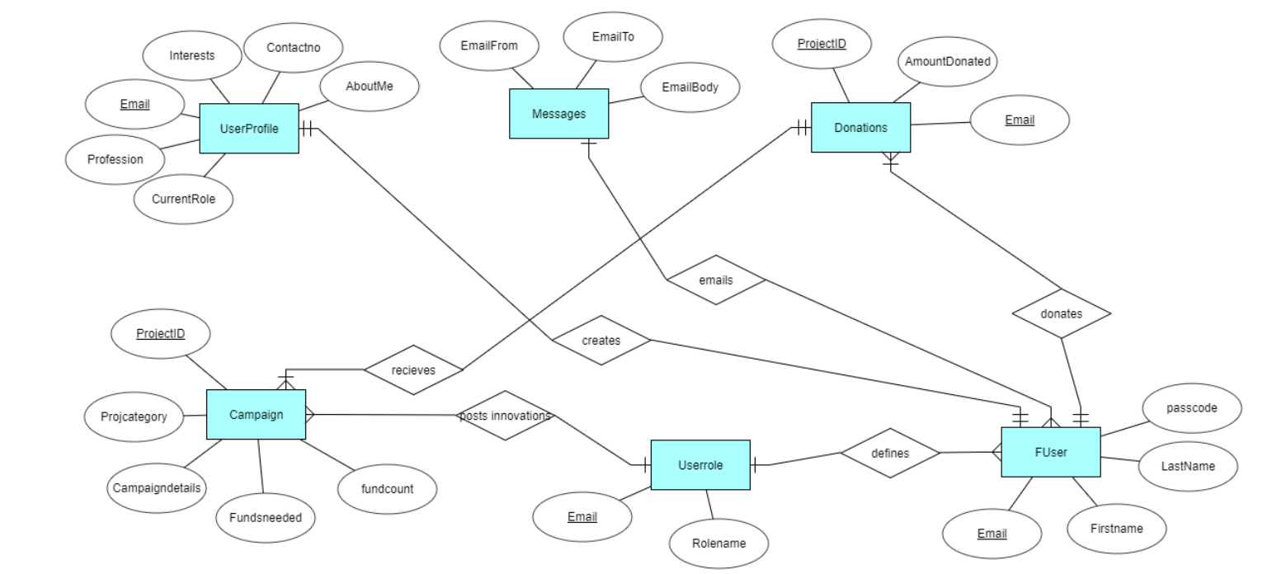

# Reverse Engineered from MySQL Workbench

